
Company
Logotype

Cone Beam Computed Tomography- Report



Porur Dental X-rays & CBCT

Patient Name : Mrs. Malarkodi | Date of Report : 22.07.2024
Age/ Gender : 62 years/ Female | Region of Interest : CBCT Mandible
Referring doctor: Dr. Divya Prasanna | Indication : Implant assessment
Clinical Notes: Nil
PATIENT INFORMATION

CBCT- Mandible provided
CBCT – IMAGE DETAILS

RADIOGRAPHIC INTERPRETATION

- Completely edentulous mandibular alveolar ridge.
- The mandibular alveolar ridge is present with normal trabecular pattern, however, due to resorptive changes of the alveolar ridge, the height of the mandible is compromised.

IMPLANT ASSESSMENT

 | 31 region | 32 region | 33 region | 34 region
Sub-Crestal (in mm) | 5.23 | 4.58 | 5.61 | 5.51
Mid- Crestal (in mm) | 5.73 | 6.16 | 7.27 | 6.78
Distance between alveolar ridge and the inferior border of mandible (in mm) | 10.7 | 11.79 | 12.4 | 10.47
 | 41 region | 42 region | 43 region | 44 region
Sub-Crestal (in mm) | 6.32 | 8.46 | 7.53 | 8.37
Mid- Crestal (in mm) | 7.72 | 9.14 | 8.2 | 9.37
Distance between alveolar ridge and the inferior border of mandible (in mm) | 11.94 | 8.27 | 9.85 | 9.3

 | 35 region | 36 region | 37 region
Sub-Crestal (in mm) | 4.7 | 9.75 | 8.69
Mid- Crestal (in mm) | - | - | -
Distance between alveolar ridge and the inferior alveolar nerve canal (in mm) | 0.8 | 0.59 | 0.79
Distance between alveolar ridge and the inferior border of mandible (in mm) | 11.33 | 7.92 | 10.35

 | 45 region | 46 region | 47 region
Sub-Crestal (in mm) | *.27 | 10.21 | 9.66
Mid- Crestal (in mm) | - | 10.05 | 8.77
Distance between alveolar ridge and the inferior alveolar nerve canal (in mm) | 0.9 | 4.26 | 3.02
Distance between alveolar ridge and the inferior border of mandible (in mm) | 12.17 | 12.49 | 13.15

RADIOGRAPHIC IMPRESSION

- Completely edentulous mandibular alveolar ridge.

Kindly correlate with clinical findings


IMAGES FOR REFERENCE

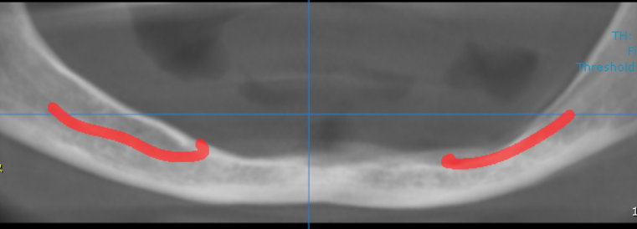

3-DIMENSIONAL VIEW

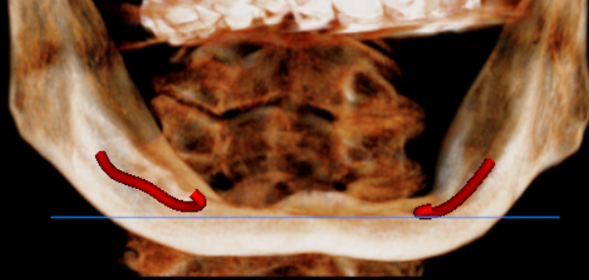

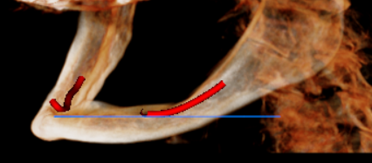
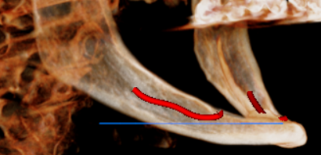

CROSS SECTIONAL VIEW

31 region | 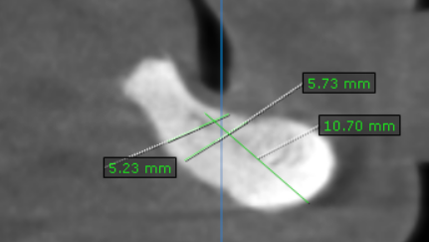
32 region | 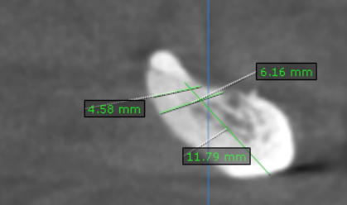
33 region | 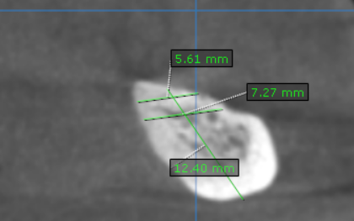
34 region | 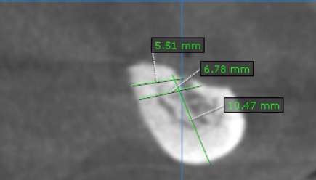
35 region | 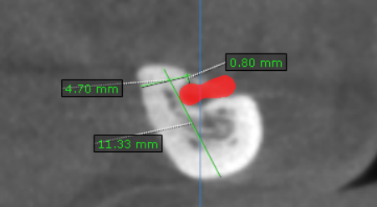
36 region | 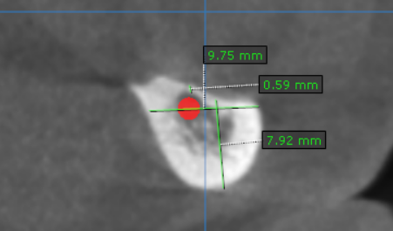
37 region | 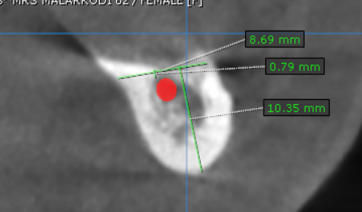
41 region | 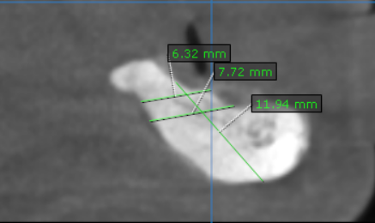
42 region | 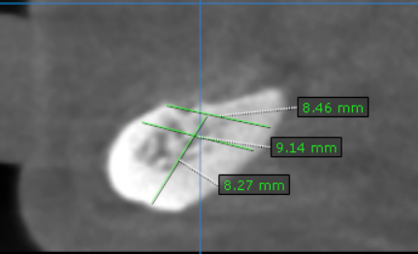
43 region | 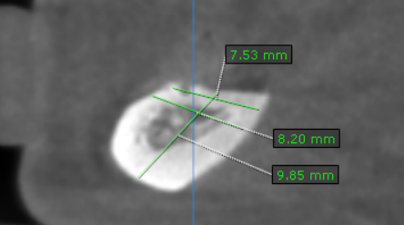
44 region | 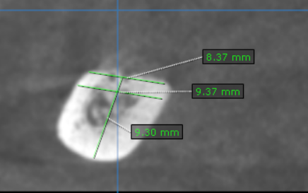
45 region | 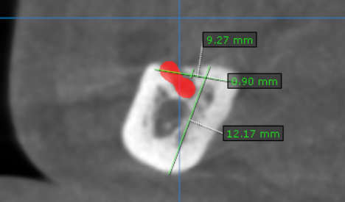
46 region | 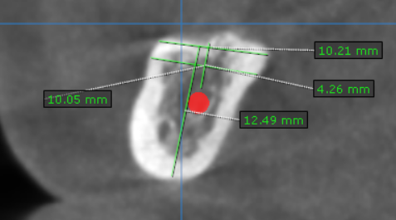
47 region | 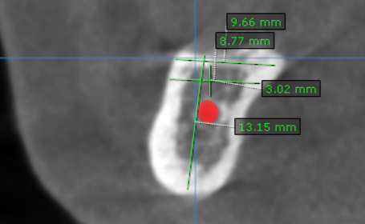

**** End of report ****

